Climate and US Migration

By:

Sanjana Chintalapudi

Sai Rohitha Challa

Minal Pawar

Table of Contents:

Abstract: 3

Introduction: 4

Data Collection and Cleaning: 5

Visualisations: 8

Research Questions and Objectives 17

Data sources: 18

References: 18

# 

# 

# 

# 

# 

# 

# 

# 

# 

# 

# Abstract:

Climate change has emerged as one of the most formidable challenges facing humanity, with its impacts resonating across the world. Annual global temperature has increased by about 1.8°F (1.0°C) according to a linear trend from 1901 to 2016. 2023 was the hottest year on record. With the rise of global temperatures and increasing frequency of climate disasters, there is a profound consequence on shifting migration and settlement patterns. Individuals and communities are grappling with the short- and long-term ramifications of environmental changes and in turn rethinking where and how they live. We are going to dive deeper into understanding how changing weather patterns and natural disasters in the United States is impacting climate migration. We are going to look at both climate disasters that could force people to migrate and the slower shifting weather patterns that changing where people may want to live. By analysing the different dimensions of migration in the United States and comparing it to national climate patterns, we will shed light on the impacts of climate change on US migration. Our goal is to comprehend the subtle effects of climate change that go beyond the obvious by looking at how shifting weather patterns affect migration to states.

# Introduction:

Climate change

Climate change has emerged as one of the most formidable challenges facing humanity, with its impacts resonating across the world. Annual global temperature has increased by about 1.8°F (1.0°C) according to a linear trend from 1901 to 2016. [1] 2023 was the hottest year on record. [2] According to National Academy of Sciences, the earth will see a greater increase in temperature in the next 50 years than compared to the whole last 6,000 years combined. Extremely hot zones like Sahara could cover fifth of the land surface by 2070 [3]. By the next century, around 3 to 6 billion people could be trapped in places facing extreme heat and food scarcity. South-Asia, which houses one-fourth of the global population, will be most affected in the near future given the current rates of global warming. In places like India and China, even a few hours outside would lead to death, with the greenhouse gas emissions unabated. [4] As the earth heats up, it has led to volatile weather patterns and more frequent climate disasters, impacting people everywhere significantly. From 2000 to 2019, there were 7,348 major recorded disaster events claiming 1.23 million lives, affecting 4.2 billion people, resulting in approximately US$2.97 trillion in global economic losses. [5] That is more than half the global population that has been affected. In 2022 alone, there were 33 million natural disaster-related displacements. [6]

Climate Migration

With the rise of global temperatures and increasing frequency of climate disasters, there is a profound consequence on shifting migration and settlement patterns. Individuals and communities are grappling with the short- and long-term ramifications of environmental changes and in turn rethinking where and how they live. This type of migration is called climate migration. Climate migration occurs when people leave their homes due to climate disasters, such as floods, droughts, and wildfires, as well as slower-moving climate challenges such as rising seas and increasing water scarcity. [9] People, regardless of immediate threat, are increasingly proactive in reevaluating their habitats. Across the United States, nearly 1 in 2 people will experience a decline in the quality of their environment, namely more heat and less water. [15] The term "billion-dollar disasters" has been coined to name the natural disasters that cause over a billion dollars in losses. These billion-dollar disasters cause about $60.5 billion in losses every year. [11] 14.5 million homes were impacted by natural disasters in 2021. That is about 1 in 10 homes in the US. [12] Droughts in the west are changing agricultural landscapes, forcing people to move due to their livelihoods.

# 

# Data Collection and Cleaning:

The data for migration within states was collected from the US Census [website](https://www.census.gov/data/tables/time-series/demo/geographic-mobility/state-to-state-migration.html), and the weather related data was collected from the National Oceanic and Atmospheric Administration ([NOAA](https://www.ncei.noaa.gov/)) website. The collected migration data includes the estimated number of people who migrated within the states in United States (internal migration) during 2005 to 2022 with the exception of data of year 2020, and for weather data, parameters like average temperature (F), average snow (in), average precipitation (in), maximum temperature (F) and minimum temperature (F) were gathered for 372 stations spread over all the states of US, except for Delaware, on a monthly basis from 2005 to 2022. The list of stations were obtained from the [Global Summary of the Month](https://www.ncei.noaa.gov/access/search/data-search/global-summary-of-the-month?pageNum=1&startDate=2005-01-01T23:59:59&endDate=2022-12-31T00:00:00) dataset of NOAA. API [link](https://www.ncei.noaa.gov/access/services/data/v1)

Weather data:

After requesting the data from NOAA, using an API, the data was cleaned, reduced and transformed into seasonal and yearly data. First, the data types of the obtained data are converted to help with further operations. All the stations didn’t have the parameters requested, resulting in a lot of blanks. To handle the NaNs and blanks, statistics like average, maximum and minimum values for the data were calculated by grouping for states and years. For data exploration, the calculated monthly statistics were further calculated for summer and winter months, where April to October are considered summer months and the rest of the months considered as winter months. The data-frames were sorted for ease of use and to help with merging the dataframes.

Initial weather data obtained:

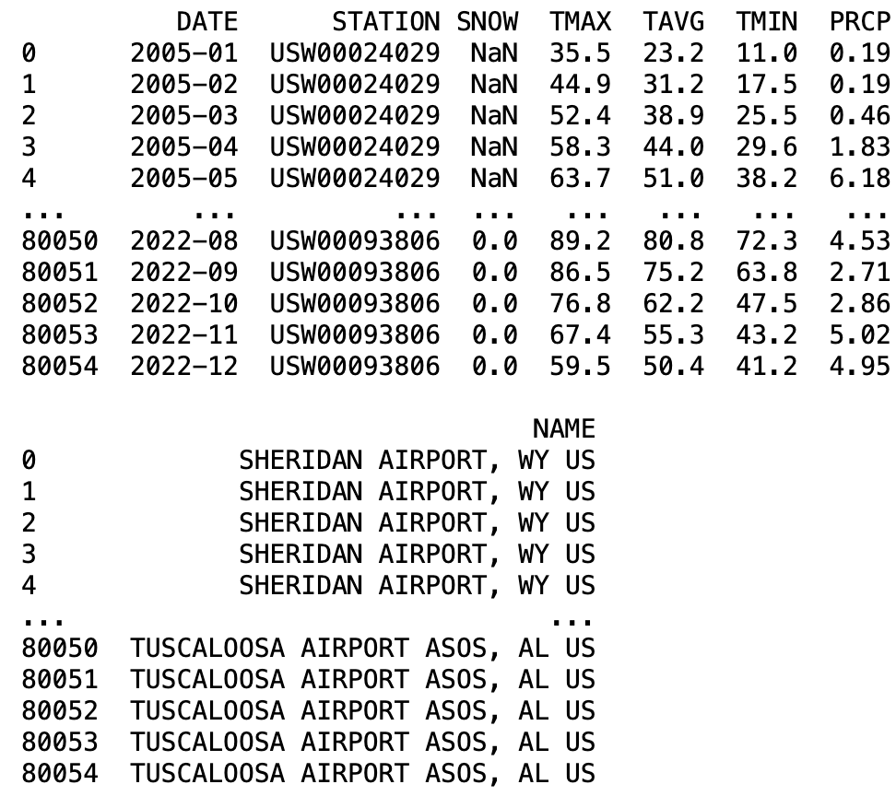

Weather Dataframe after data-cleaning:

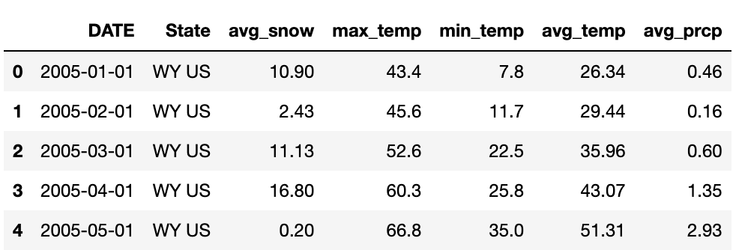

Migration data:

For migration data, the preliminary data cleaning was done using MS Excel, as the table formats in the files changed over the years. The given data was a cross table for all the states that includes the in-state population, the population that moved from one state to another and the margin of error of census data. The datasets on the website were given per year, so combined 17 years of data files into one large dataframe. Since the data was given in segments, we transformed the dataset and calculated variables that can be leveraged in our analysis, Total_Pop, Percentage, Top1, Top1 State.

Total_Pop : We calculated the total population for each state per year, by adding the population currently living in that state and summing the populations that moved from other states to that current state.

Percentage: The percentage was calculated by dividing the people that moved to the state (Total Population - In-state population) by total population.

Top1 : We found the top state that people moved from into the current state and the population moved by using the max function.

Top1_State : The top1 population variable identified the top state.

The excel sheets with these parameters data were read into separate data-frames. The data-frames were concatenated and cleaned. Unnecessary columns were dropped and the percentage column was transformed to show the values in percentages. After dropping the data for Delaware, District of Columbia, Puerto Rico (District of Columbia and Puerto Rico data was dropped as they weren’t states), the weather and migration data-frames were merged on state and date columns.

Initial migration data obtained:

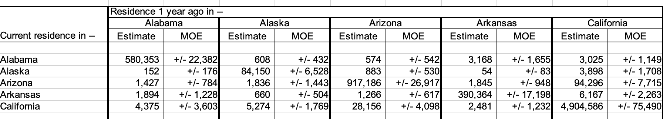

Migration Data-frame after data-cleaning:

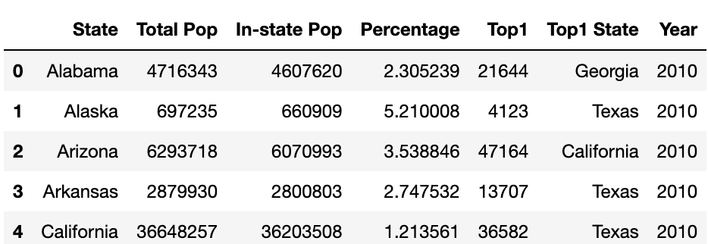

Both the Weather and the Migration data-frames didn’t have any missing values, NaN values or blanks after the data cleaning. There were data-points with average snow as zero, this data is to be expected for some years and states.

We merged the weather and migration data frames so that each state and its corresponding year had both the migration data and the weather data. We did some additional cleanup by using the state’s full name instead of its abbreviation and changing the date column to a year column. 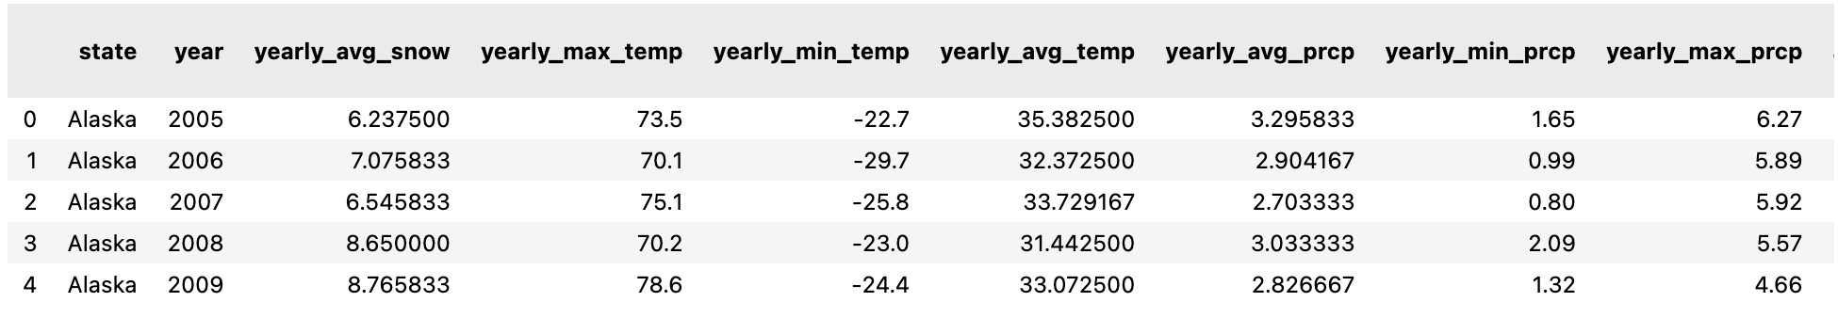

The merged data frame has 24 columns representing the data across movement between states and the state’s weather patterns.

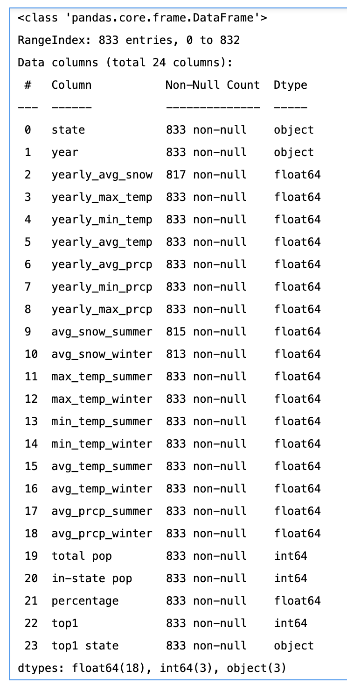

We analysed the distribution of the data for the merged data-frame using qq plots. From the qq-plots of the merged distribution, we could see that in the weather related columns, temperature appears to be relatively normally distributed, while the migration related columns are non-normally distributed.

# Visualisations:

To explore the weather data and migration data for the United States, we used visualisations so that we can uncover initial patterns. Link of [website](https://sites.google.com/view/sanjminalchala/introduction/project-introduction?authuser=2).

First we started by looking at the weather patterns across the years and the states.

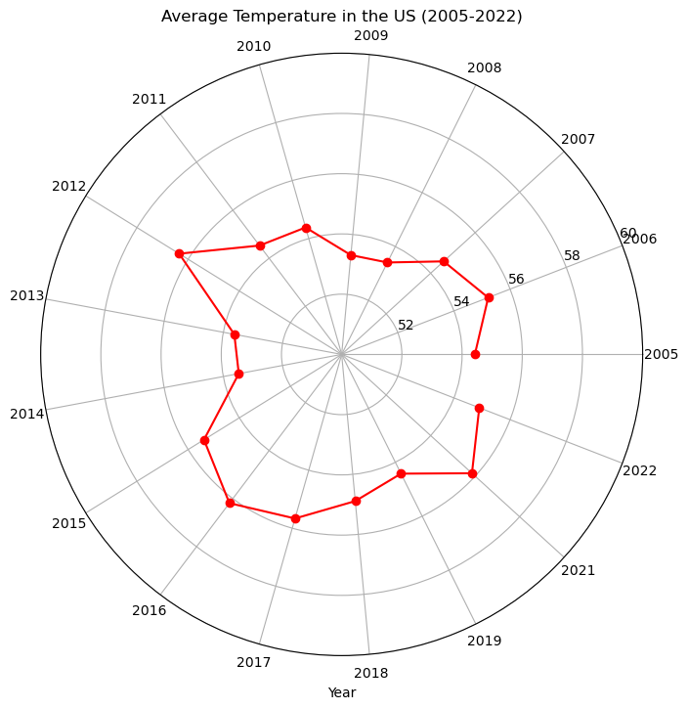

In the above plot we can see that the average temperatures in the United States are showing a cyclical behaviour with consecutive high and low dips in the temperature with the mean average temperature 55F and the range being 53F to 56.5F.

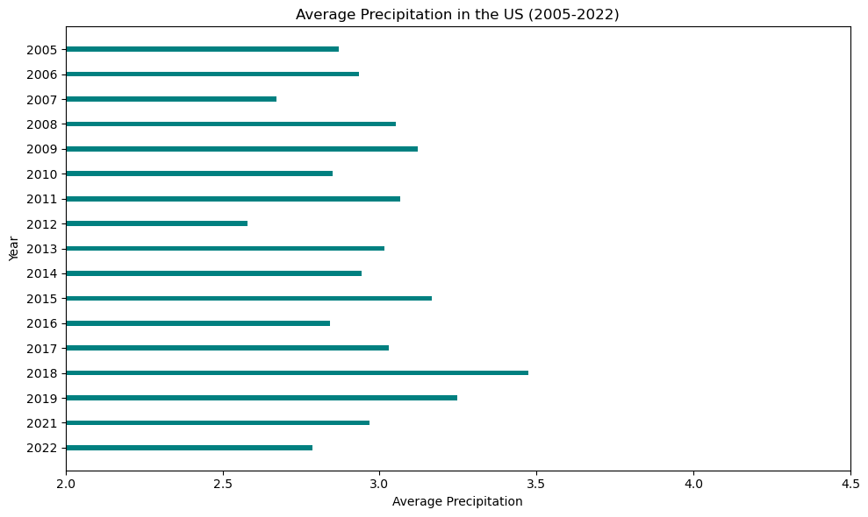

The above plot shows the average precipitation (in) in the United States over the years, with the mean precipitation being 3 inches. Concerningly, we can see that after 2018, average precipitation is declining.

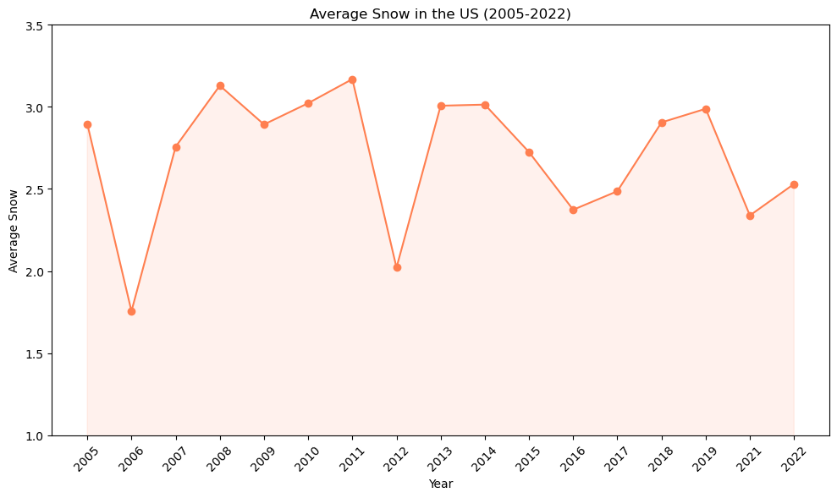

The above plot shows us the average snow(in) in the United States from 2005 to 2022. There is a sharp drop in the average snow in 2006 and 2012, after that the average snow ranges between 2 to 3 inches a year.

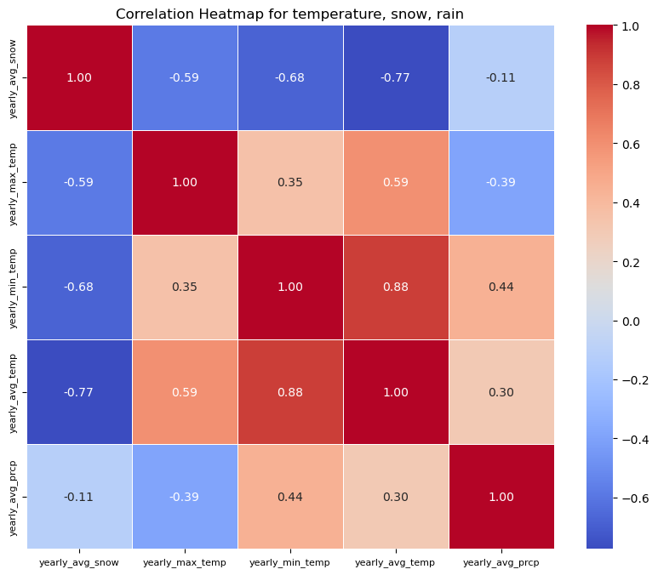

The above heatmap shows the correlation between the temperatures, snow and rain. We can see that the average snow has the highest correlation with average temperature and then with minimum temperature. Lets see how exactly the data is distributed with the help of scatter plots.

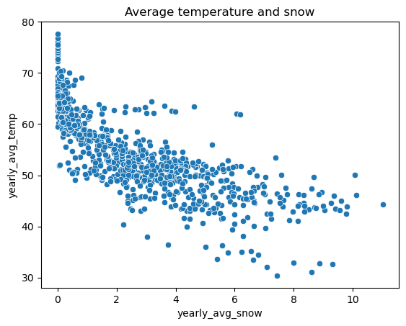

The above scatterplot shows that the yearly average snow and yearly average temperature tend to move together.

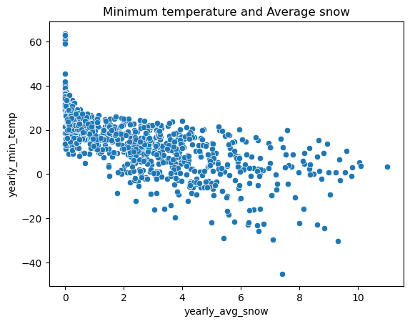

The above scatterplot shows that the yearly average snow and yearly minimum temperature tend to move together. We did not find any worthwhile trends when looking at temperature and precipitation.

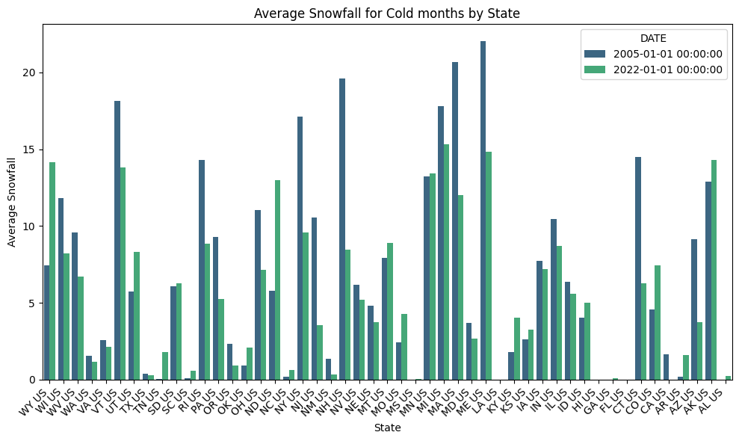

The above graph compares snowfall in the winter by state in 2005 and 2022. In most states, it appears that snowfall was more prevalent in 2005 compared to 2022. This aligns with the broader trends of climate change, including rising global temperatures resulting in lower snow patterns.

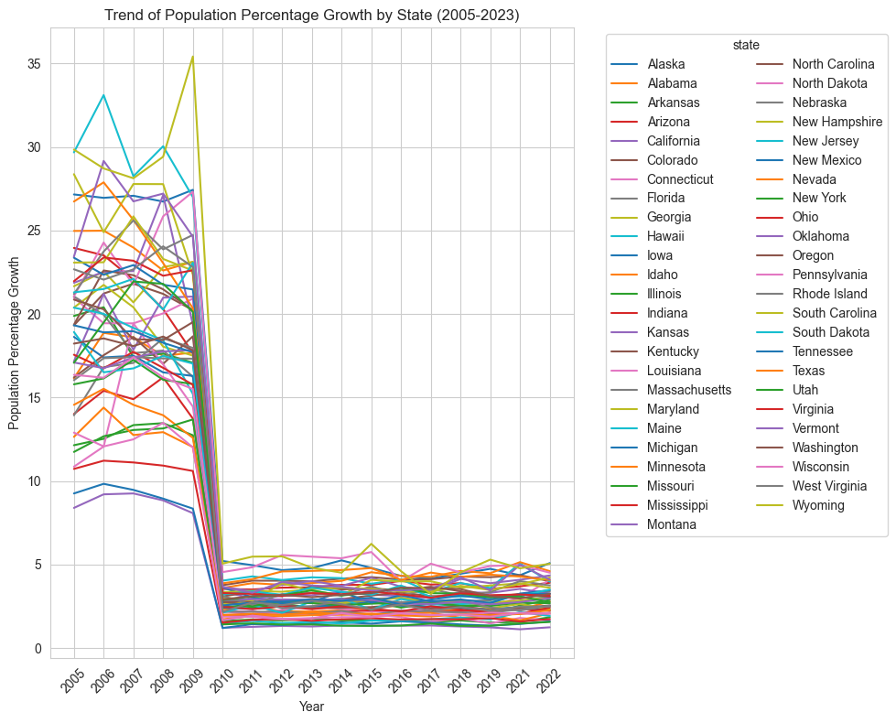

To better understand the migration patterns for each of the states, we plotted migration trends over the years for each state. The line plot shows a significant common trend across all the states; between 2009 and 2010, every state’s population growth percentage dropped from over 5% to under 5%. One can speculate that the drop could be associated by the major event in the United States at that time, the Great Recession. To analyse the states’ migration data better, we split the data to look at 2005-2009 together and the data between 2010-2022 together.

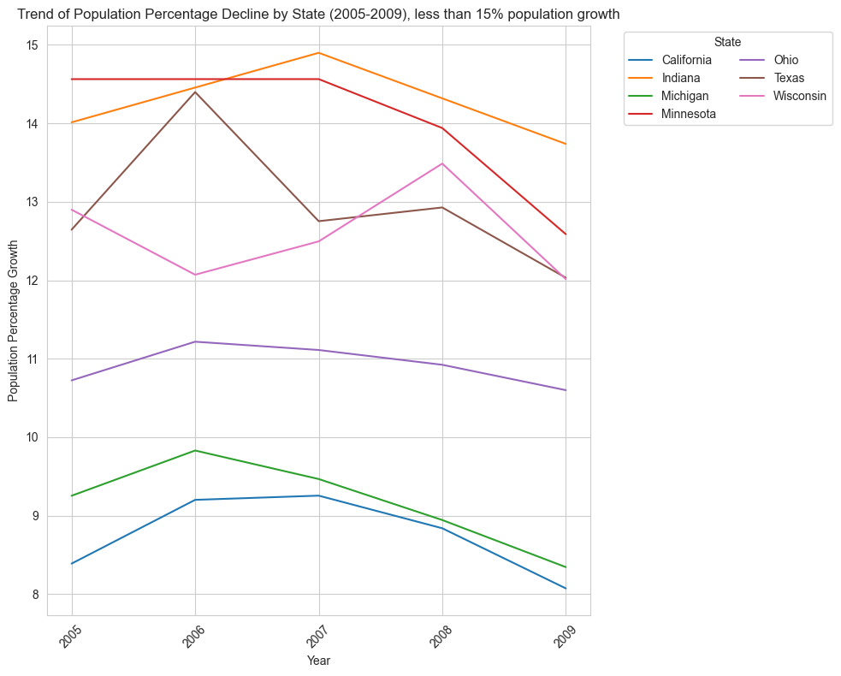

We first focused on exploring migration data from 2005 to 2009. We found that there were specific states that had decreasing population growth and significantly less population growth than most other states: less than 15%. California and Michigan had lower population growth than most states, less than 10% and declining.

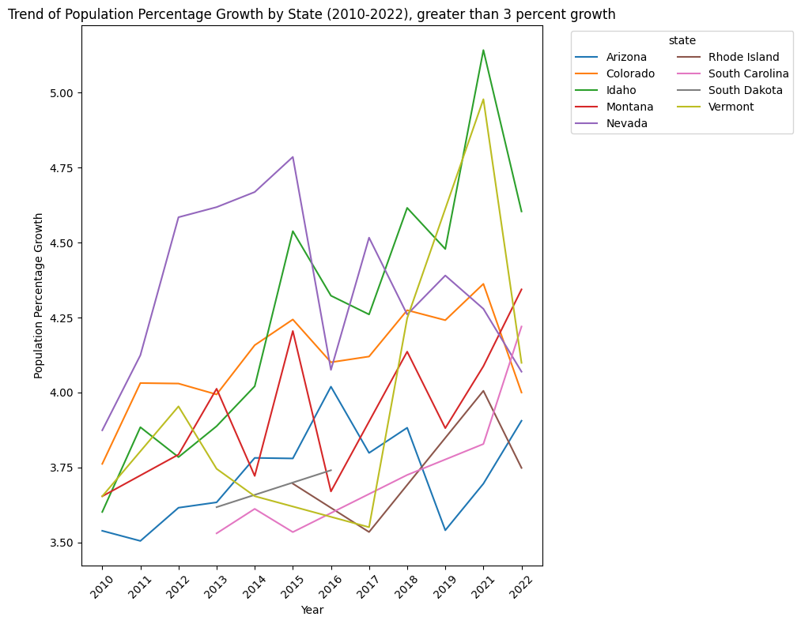

Between 2010 and 2022, most states did not have more than 10% population growth. There were specific states that were increasing greater than 3 percent and exponentially over most other states. In Vermont, there was a significant increase in population between 2017 and 2021. Keep in mind that there is no data for 2020, due to Covid so there is a gap for that year. Idaho had the most significant population growth percentage between 2010 and 2022 with over 5% in 2021.

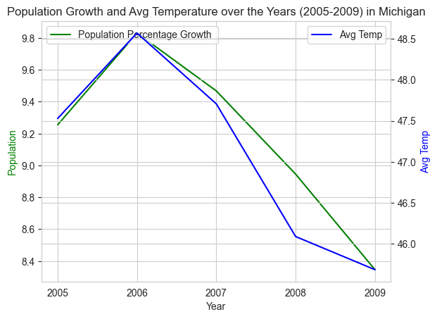

In Michigan, average temperature and population growth percentage had similar trend lines throughout 2005 and 2009. Between 2005 and 2006, population growth and average temperature increased. Between 2006 and 2009, the population percentage decreased and so did the average temperature. Both population growth and average temperature had similar slopes throughout the increase and the decrease.

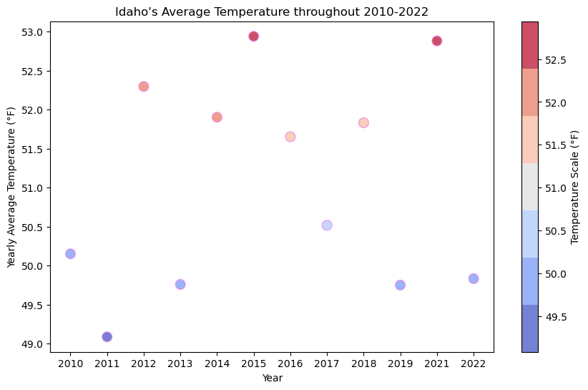

Idaho’s average temperature throughout 2010 to 2022 stayed consistent - around the 50s.

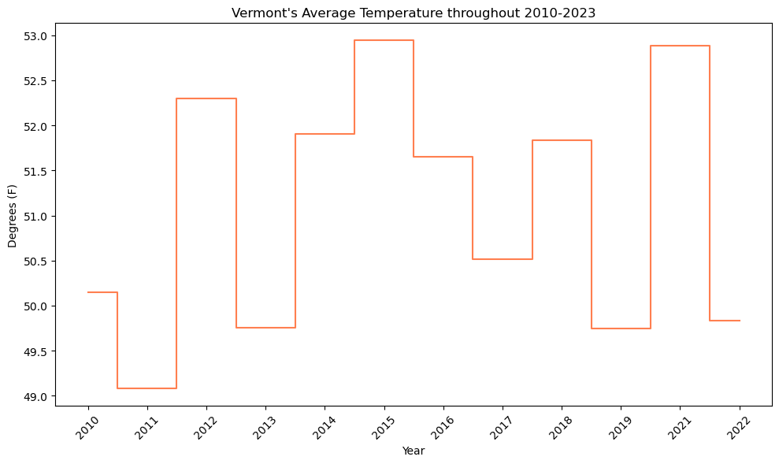

Vermont’s average temperature throughout 2010 to 2022 stayed consistent - around the high 40s, between 44 and 48 degrees Fahrenheit.

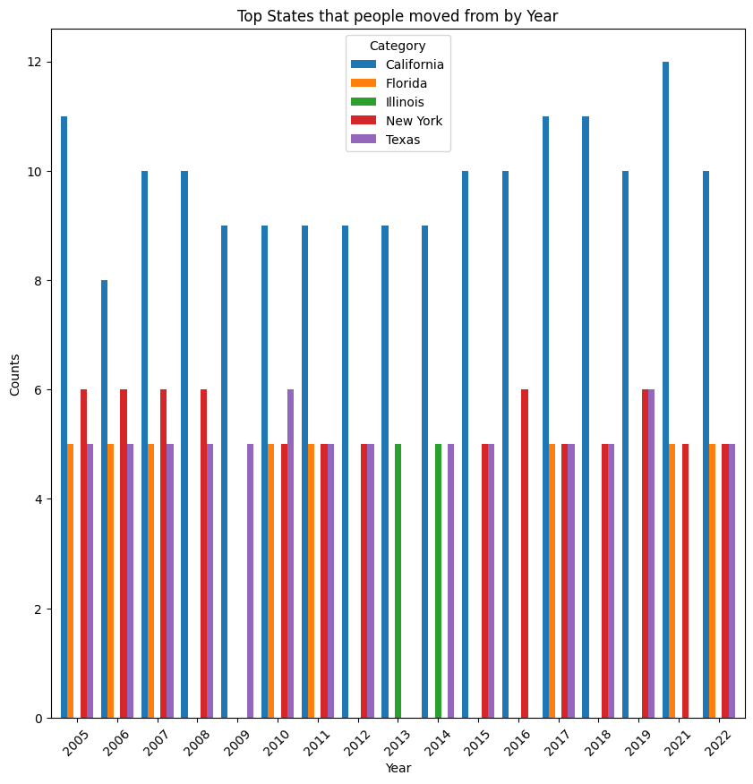

The above graph shows the top states that people move from to another state by year. The top states are California, Florida, Illinois, New York and Texas. California is the top state that people move from throughout 2005 and 2022, surpassing other states throughout those years.

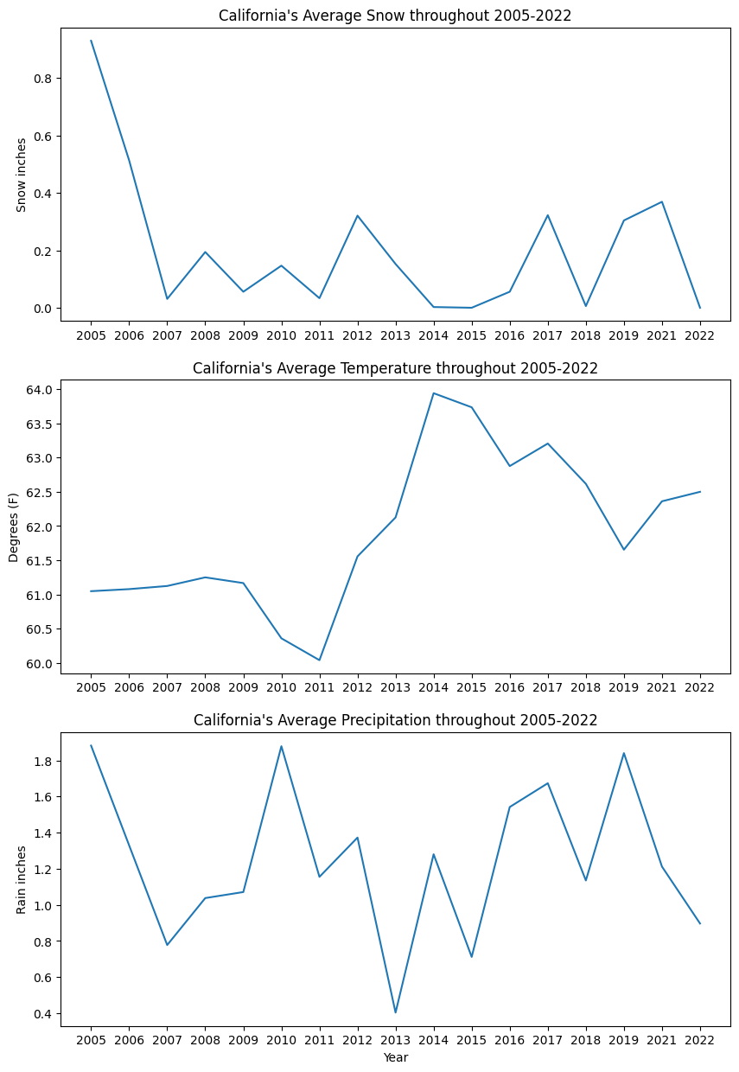

California’s average temperature increased by 3 points between 2011 and 2015. California’s snowfall dropped by a quarter since 2005. California’s rainfall is also volatile with it fluctuating between less than 1in to no more than 2 inches throughout the last 17 years.

# Research Questions and Objectives

We are going to dive deeper into understanding how changing weather patterns and natural disasters in the United States is impacting climate migration. We are going to look at both climate disasters that could force people to migrate and the slower shifting weather patterns that changing where people may want to live. By analyzing the difference dimensions of migration in the United States and comparing it to national climate patterns, we will shed light on the impacts of climate change on US migration. Our goal is to comprehend the subtle effects of climate change that go beyond the obvious by looking at how shifting weather patterns affect migration on states. In addition, we want to determine the socioeconomic and demographic variables that influence migration. Our research aims to evaluate the following questions:

* How do changing weather patterns influence migration patterns in the United States?
* What are the socioeconomic factors driving climate-induced migration?
* What are the variations in migratory patterns caused by climate change among distinct demographic categories?
* How are households migration affected by climate change?
* How are people migrating based on age demographics?
* What states are going to be more populated in the next 5 years?
* What regions are going to be more affected by weather patterns and natural disasters and what is the population there going to be?
* How are regions with seasonal changes affecting migration patterns versus regions that are mostly consistent throughout the year?
* What type of natural disasters cause people to migrate?
* How has changes in natural disasters in an area impacted migration?

# Data sources:

[1]<https://www.census.gov/data/tables/time-series/demo/geographic-mobility/state-to-state-migration.html>

[2] <https://www.ncei.noaa.gov/>

# References:

[1]<https://nca2018.globalchange.gov/chapter/2/>

[2<https://www.climate.gov/news-features/understanding-climate/climate-change-global-temperature#:~:text=2023%20was%20the%20warmest%20year,1850%20by%20a%20wide%20margin>.

[3]<https://features.propublica.org/climate-migration/model-how-climate-refugees-move-across-continents/>

[4]<https://www.propublica.org/article/climate-crisis-niche-migration-environment-population>

[5]<https://www.undrr.org/publication/human-cost-disasters-overview-last-20-years-2000-2019>

[6]<https://www.migrationpolicy.org/article/climate-migration-101-explainer#origins>

[7]<https://openknowledge.worldbank.org/entities/publication/2be91c76-d023-5809-9c94-d41b71c25635>

[8]<https://news.un.org/en/story/2021/09/1098662>

[9]<https://www.cfr.org/in-brief/climate-change-fueling-migration-do-climate-migrants-have-legal-protections#:~:text=Climate%20migration%20occurs%20when%20people,seas%20and%20intensifying%20water%20stress>

[10]<https://link.springer.com/article/10.1007/s11111-017-0290-2>

[11]https://www.ncei.noaa.gov/access/billions/

[12]<https://www.forbes.com/home-improvement/features/americans-moving-climate-change/>

[13] https://www.policygenius.com/homeowners-insurance/home-insurance-pricing-report-2023/

[14]<https://www.cnn.com/2023/11/07/homes/homeowners-insurance-climate-real-estate/index.html>

[15] https://www.propublica.org/article/climate-change-will-force-a-new-american-migration